Web Application.
I first created a Trello board to map out what needed doing as per the requirement on Engagedly which can be seen below, I’ve just moved some around to fit them all on the page so you can see them, they’re now all done I’d like to think:
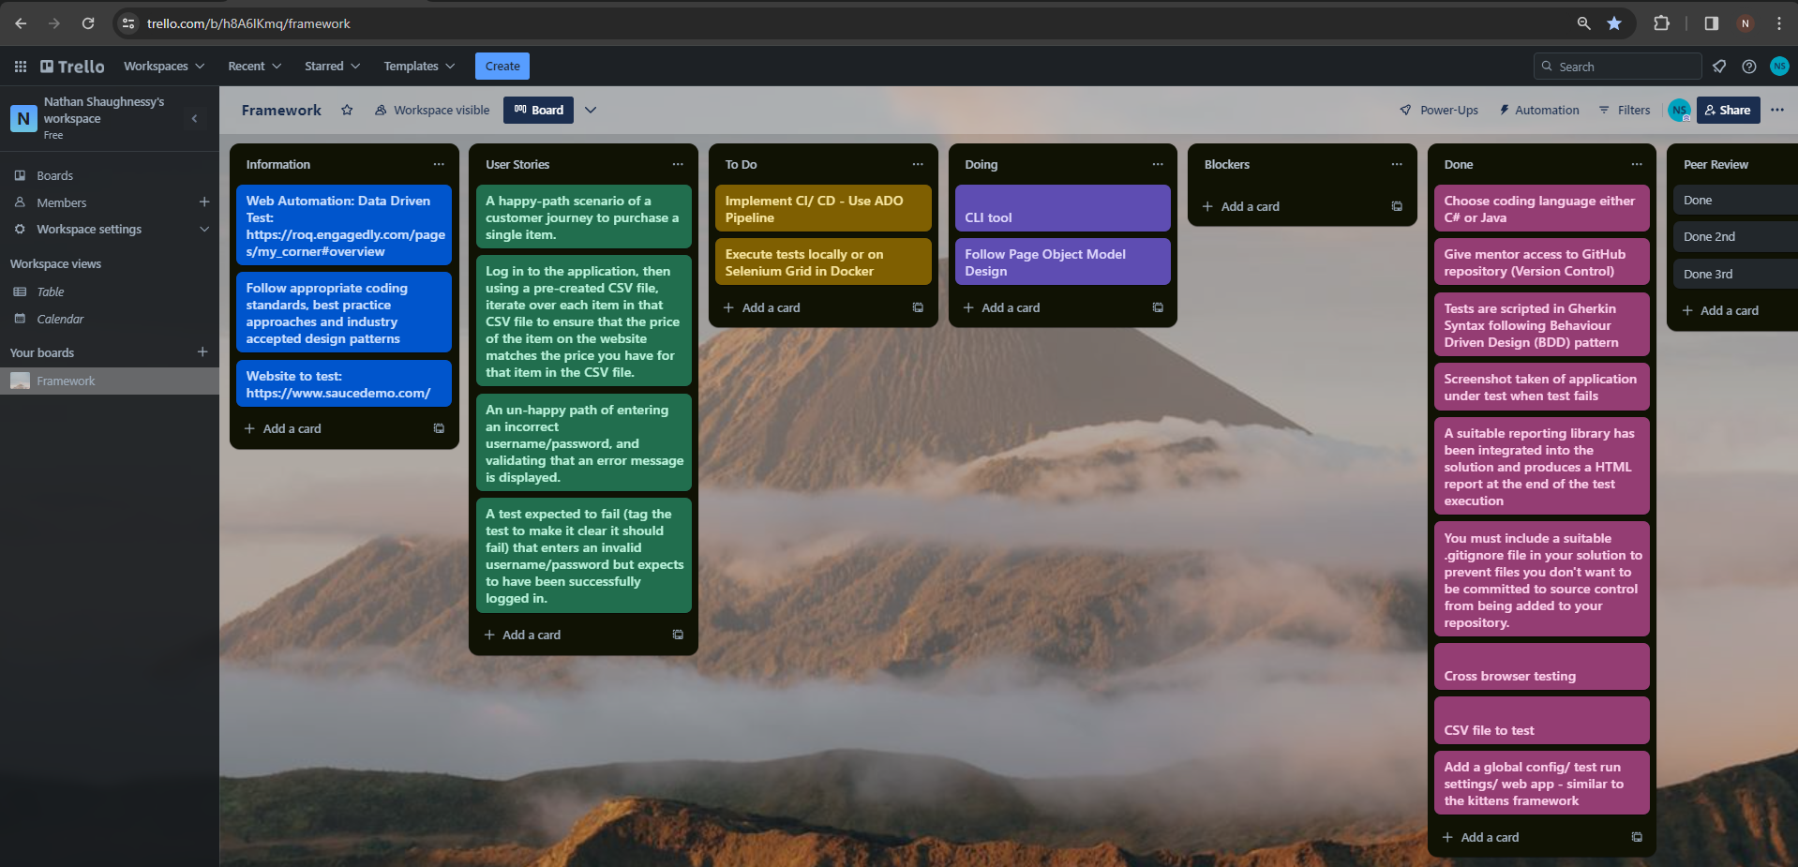
I opted for C# as the programming language to build my Web Automation testing framework in Visual Studio. I chose to do a SpecFlow project as this tool allowed me to follow a Behavior-Driven Development (BDD) approach, allowing tests to be scripted in Gherkin syntax which are easily readable. Gherkin syntax serves as a human-readable language for test scenarios, bridging the communication gap between technical and non-technical stakeholders
GitHub was integrated for version control, ensuring traceability of all the changes I committed and pushed on various branches before merging them into the main branch. When creating the Specflow project I was able to do this all in one and added the .gitignore file here too to prevent the committing of irrelevant information.
I employed the Page Object Model (POM) for a modular and maintainable design. Each web page or component is represented as a separate class, enhancing the structure and reusability of the automated tests.
I split my framework up into my main folders – one regarding the application with an Elements folder for the element wrapper and a Pages folder with the individual page classes. A drivers folder for my DriverManager class, Test results folder which holds an failed tests screenshots and my HTML reporting, a tests folder which an execution folder holding my hooks class, feature folder with feature files, Step Deifition folder for my step def classes for each page and lastly a Utility folder with the exten report class. In the main directory I have my .gitattributes, .gitignore, implicit using class and my Test Run Settings file.
I began my framework by creating my Feature files for each scenario provided in the requirement using the Gherkin syntax. Following the scripting of those, I defined the steps and added them to the subsequent step definition classes regarding which page it affected. This included adding a CSV file into the Feature folder’s area and in the subsequent feature file regarding the CSV test I used the nuget package SpecFlow.externaldata to connect the feature file to the csv file.
Breakdown of one of the Step Definitions:
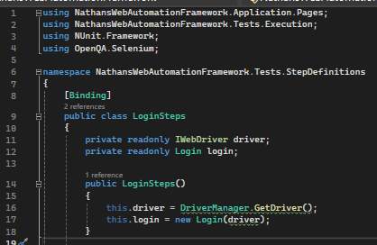
Namespaces and class declaration:
- Namespaces: It includes references to the application pages, test execution, NUnit framework, and Selenium.
- Class Declaration: It declares the LoginSteps class, which is a part of the StepDefinitions namespace and is marked with the [Binding] attribute indicating that it contains SpecFlow bindings.
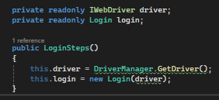
Class Constructor:
- IWebDriver: Declares a private readonly field driver of type IWebDriver, representing the Selenium WebDriver.
- Login: Declares a private readonly field login of type Login, which is a page object representing the login page.
- Constructor: Initializes the driver field by getting the driver instance from DriverManager and initializes the login field by creating a new instance of the Login page object, passing the driver instance.
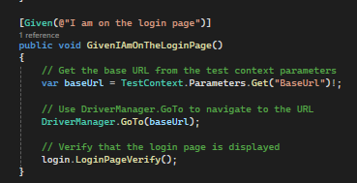
GivenIAmOnTheLoginPage Method:
- SpecFlow Step: It is marked with the [Given] attribute, representing the Given step in Gherkin syntax.
- URL Navigation: Retrieves the base URL from the test context parameters.
- Navigation: Uses the DriverManager.GoTo method to navigate to the specified URL.
- Verification: Calls the LoginPageVerify method on the login instance to ensure that the login page is displayed.

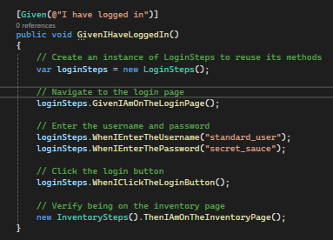
GivenIHaveLoggedIn Method:
- SpecFlow Step: It is marked with the [Given] attribute, representing the Given step in Gherkin syntax.
- Reusability: Creates an instance of LoginSteps to reuse its methods.
- Navigation and Interaction: Calls the methods from loginSteps to navigate to the login page, enter a username and password, click the login button.
- Verification: Instantiates InventorySteps and calls its method to verify being on the inventory page.
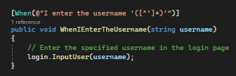
WhenIEnterTheUsername Method:
- SpecFlow Step: It is marked with the [When] attribute, representing the When step in Gherkin syntax.
- Interaction: Calls the InputUser method on the login instance to enter the specified username in the login page.
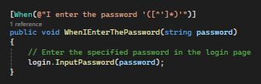
WhenIEnterThePassword Method:
- SpecFlow Step: It is marked with the [When] attribute, representing the When step in Gherkin syntax.
- Interaction: Calls the InputPassword method on the login instance to enter the specified password in the login page.
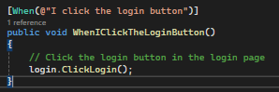
WhenIClickTheLoginButton Method:
- SpecFlow Step: It is marked with the [When] attribute, representing the When step in Gherkin syntax.
- Interaction: Calls the ClickLogin method on the login instance to click the login button in the login page.
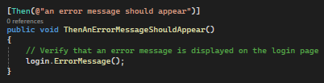
ThenAnErrorMessageShouldAppear Method:
- SpecFlow Step: It is marked with the [Then] attribute, representing the Then step in Gherkin syntax.
- Verification: Calls the ErrorMessage method on the login instance to ensure that an error message is displayed on the login page.

Once I had those, I began creating the Page classes in the Application, finding the relevant elements and creating methods. I only added an element wrapper later on aafter a Chat with James about best practices.
The ElementWrapper class is a utility class designed to simplify interactions with web elements using Selenium in a more readable and reusable manner. It acts as a wrapper around the Selenium IWebDriver and provides methods for common operations on web elements.
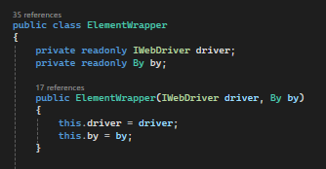
Constructor:
- Takes an IWebDriver instance and a By locator.
- Initializes the driver and by fields with the provided values.
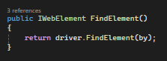
FindElement Method:
- Uses the driver to find a single IWebElement based on the provided By locator.
- Returns the found element.
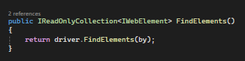
FindElements Method:
- Uses the driver to find a collection of IWebElements based on the provided By locator.
- Returns the found collection.
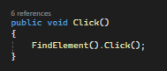
Click Method:
- Calls the FindElement method internally to locate the element.
- Performs a click action on the located element.
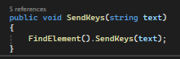
SendKeys Method:
- Calls the FindElement method internally to locate the element.
- Sends the specified text to the located element.
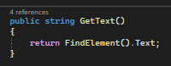
GetText Method:
- Calls the FindElement method internally to locate the element.
- Retrieves and returns the text content of the located element.
By encapsulating these common operations within the ElementWrapper class, you can create more readable and maintainable automation code. It also promotes reusability by allowing you to handle interactions with web elements consistently throughout your test framework.

So now I have my Application folder with Element wrapper and page classes with methods called in the Step definitions linking to the feature files I then added my Hooks class and HTML reporting with Screenshots for failures. I did this by following a video on Youtube.
Hook’s class:
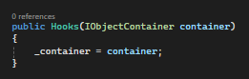
Constructor:
- This is the constructor of the Hooks class, which initializes the _container field. The IObjectContainer is a dependency injection container provided by SpecFlow.
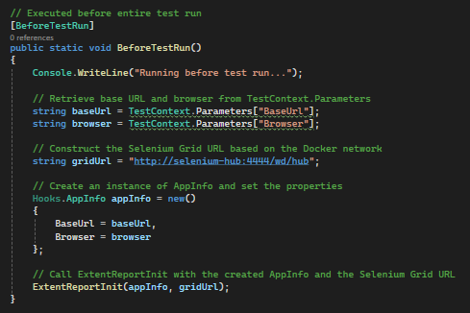
Before Test Run
- This method is decorated with [BeforeTestRun] attribute, indicating that it will be executed before the entire test run.
- It initializes some information (like base URL and browser) and sets up the Selenium Grid URL.
- It creates an instance of the AppInfo class and initializes the ExtentReport using the ExtentReportInit method.
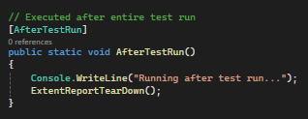
- This method is decorated with [AfterTestRun] attribute, indicating that it will be executed after the entire test run.
- It finalizes the ExtentReport using the ExtentReportTearDown method.
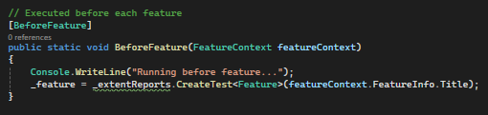
- This method is decorated with [BeforeFeature] attribute, indicating that it will be executed before each feature.
- It sets up the ExtentReport for the specific feature.#

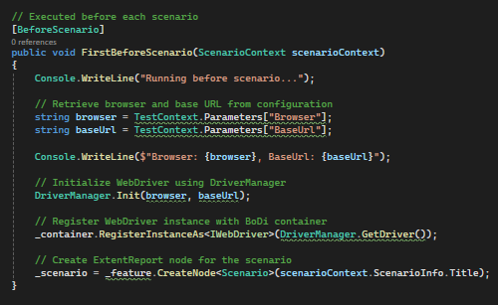
- This method is decorated with [BeforeScenario] attribute, indicating that it will be executed before each scenario.
- It initializes WebDriver, registers it with the BoDi container, and creates an ExtentReport node for the scenario.
  - [BeforeScenario] attribute: This indicates that the method (FirstBeforeScenario) will be executed before each scenario.
  - Console.WriteLine("Running before scenario...");: This prints a message to the console indicating that the setup for the scenario is starting.
  - Browser and Base URL retrieval:
    - string browser = TestContext.Parameters["Browser"];
    - string baseUrl = TestContext.Parameters["BaseUrl"];
  - These lines retrieve the browser and base URL from the test context parameters. Test context parameters are typically set in your test configuration or from command-line parameters.
  - Console.WriteLine($"Browser: {browser}, BaseUrl: {baseUrl}");: This prints the browser and base URL to the console for informational purposes.
  - DriverManager.Init(browser, baseUrl);: This initializes the WebDriver using the DriverManager class (assuming you have a class named DriverManager for managing your WebDriver instances). It configures the WebDriver based on the specified browser and base URL.
  - _container.RegisterInstanceAs<IWebDriver>(DriverManager.GetDriver());: This registers the WebDriver instance as an instance of IWebDriver with the BoDi container. BoDi (Behavior-Driven Development Container) is a dependency injection container provided by SpecFlow. Registering the WebDriver allows it to be shared and injected into your step definitions.
  - _scenario = _feature.CreateNode<Scenario>(scenarioContext.ScenarioInfo.Title);: This creates a new ExtentReport node for the current scenario using the _feature instance (which represents the current feature). It uses the title of the scenario obtained from the scenarioContext.
In summary, this part of the code sets up the environment for each scenario. It initializes the WebDriver, registers it with the BoDi container for dependency injection, and creates an ExtentReport node to log information about the scenario.
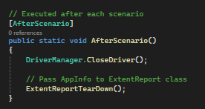
After Scenario
- This method is decorated with [AfterScenario] attribute, indicating that it will be executed after each scenario.
- It closes the WebDriver and finalizes the ExtentReport.
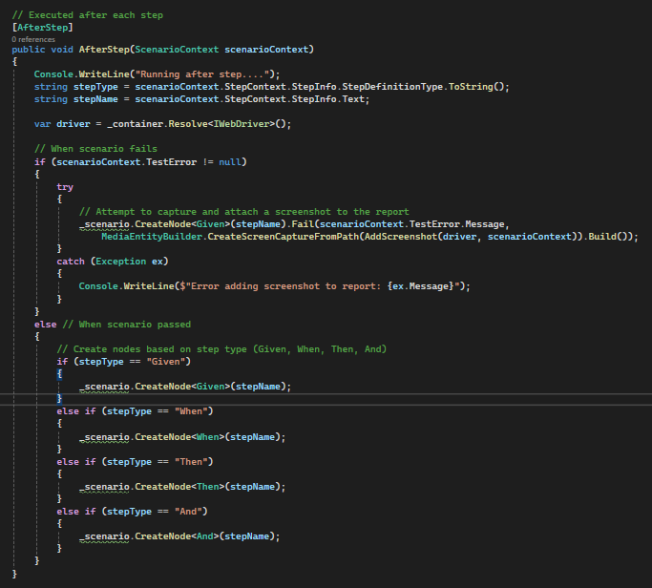
After Step
- This method is decorated with [AfterStep] attribute, indicating that it will be executed after each step.
- It captures screenshots on step failure and adds nodes to the ExtentReport.
  - [AfterStep] attribute: This indicates that the method (AfterStep) will be executed after each step.
  - Console.WriteLine("Running after step....");: This prints a message to the console indicating that the cleanup for the step is starting.
  - string stepType = scenarioContext.StepContext.StepInfo.StepDefinitionType.ToString();: This retrieves the step type (Given, When, Then, And) and converts it to a string.
  - string stepName = scenarioContext.StepContext.StepInfo.Text;: This retrieves the text of the step.
  - var driver = _container.Resolve<IWebDriver>();: This resolves the IWebDriver instance from the BoDi container. This assumes that IWebDriver was previously registered during the scenario setup.
  - if (scenarioContext.TestError != null): This checks if there was an error during the execution of the step.
  - Inside the if block:
  - It attempts to capture a screenshot and attach it to the ExtentReport node if an error occurred.
  - The specific step type (Given) is used for the node creation.
  - The screenshot is captured using the AddScreenshot method.
  - Inside the else block:
  - When the scenario passes, it creates nodes based on the step type (Given, When, Then, And).
  - The corresponding node type (Given, When, Then, And) is determined based on the step type.
In summary, this part of the code is executed after each step in a scenario. It captures and attaches screenshots for failed steps, and it creates ExtentReport nodes for each step, categorizing them based on their step type.

Extent Report Class
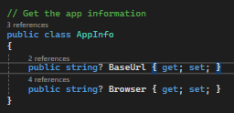
- This is a simple class to store application information (base URL, browser).
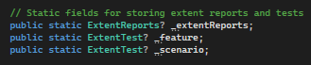
- These are static fields to hold the instance of ExtentReports and ExtentTest.
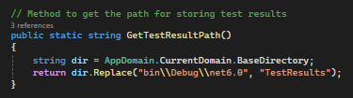
- This method returns the path where the test results and screenshots will be stored.
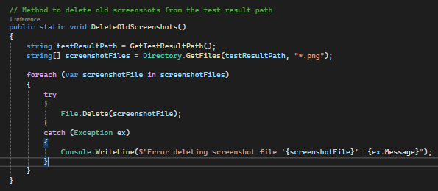
- This method deletes old screenshot files from the test result path.
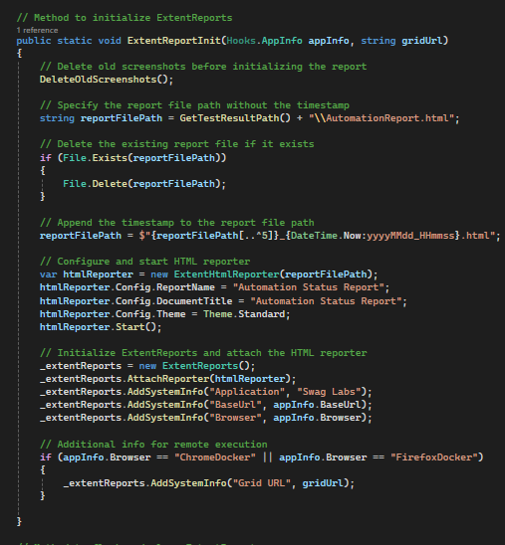
- This method initializes the ExtentReports, attaches an HTML reporter, and adds system information.
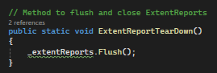
- This method flushes and closes the ExtentReports
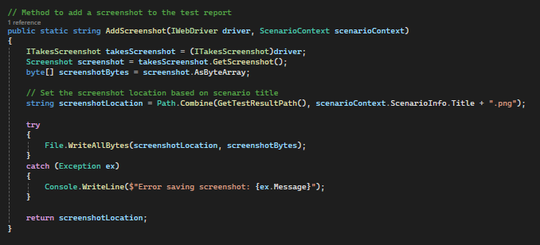
- This method captures a screenshot using the WebDriver, saves it, and returns the screenshot location.
These classes are responsible for setting up, managing, and finalizing the ExtentReports for your SpecFlow tests, including capturing screenshots and logging test information.

For the cross browser testing I added the Driver Manager Class which linked up to the Test Run Settings file, in the cross browser testing section I also set up docker to be run on the selenium grid:
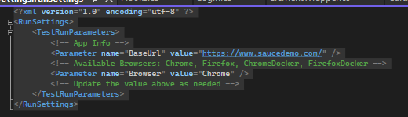
- This XML file appears to be a configuration file used with Visual Studio's Test platform.
- <?xml version="1.0" encoding="utf-8" ?>: This declaration specifies that the document is an XML file and defines the version of XML and the character encoding used.
- <RunSettings>: This is the root element of the XML file. It contains settings for the test run.
- <TestRunParameters>: This section contains parameters specific to the test run.
- <!-- App Info -->: This is an XML comment, providing a note or description for human readers. In this case, it indicates that the following parameter is related to application information.
- <Parameter name="BaseUrl" value="https://www.saucedemo.com/" />: This defines a parameter named "BaseUrl" with a value of "https://www.saucedemo.com/". This parameter likely represents the base URL of the application being tested.
- <!-- Available Browsers: Chrome, Firefox, ChromeDocker, FirefoxDocker -->: Another comment indicating the available browser options for the test run.
- <Parameter name="Browser" value="Chrome" />: This defines a parameter named "Browser" with a default value of "Chrome". It likely represents the browser in which the tests will be executed. Options include "Chrome", "Firefox", "ChromeDocker", and "FirefoxDocker".
- <!-- Update the value above as needed -->: A comment suggesting that the user should update the value of the "Browser" parameter based on their requirements.
- In summary, this XML file is a configuration file for test run settings. It includes parameters for the base URL of the application under test and the browser to be used during the test run. Users can customize these parameters as needed for their testing environment.
Driver Manager class:
This C# code defines a static class named DriverManager, which is responsible for managing the WebDriver instances used in the test automation framework. Let's break down the key components:
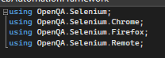
- These are the necessary using directives to import Selenium WebDriver-related classes and dependencies.
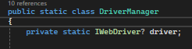
- `private static IWebDriver? driver;: This private static field holds the WebDriver instance. It's declared as nullable (IWebDriver?) to allow for cases where the driver might not be initialized.
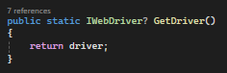
- public static IWebDriver? GetDriver(): This method returns the current WebDriver instance.
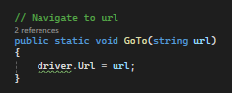
- public static void GoTo(string url): This method navigates the current WebDriver instance to the specified URL.
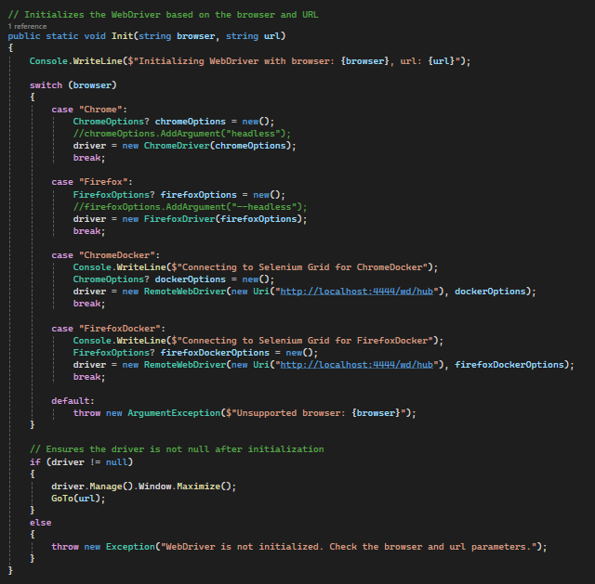
- public static void Init(string browser, string url): This method initializes the WebDriver based on the specified browser and URL.
  - Console Output: The method starts by printing a message to the console, indicating the browser and URL being used for initialization.
  - Switch Statement: The method uses a switch statement to handle different browsers. It creates and configures the WebDriver instance based on the specified browser.
  - "Chrome": It initializes a Chrome WebDriver. You can uncomment //chromeOptions.AddArgument("headless"); to run Chrome in headless mode.
  - "Firefox": It initializes a Firefox WebDriver. You can uncomment //firefoxOptions.AddArgument("--headless"); to run Firefox in headless mode.
  - "ChromeDocker" and "FirefoxDocker": It connects to a Selenium Grid for Chrome or Firefox running in a Docker container.
  - Ensuring Driver Initialization: After initializing the driver, the method ensures that the driver object is not null. If it is not null, it maximizes the browser window and navigates to the specified URL using the GoTo method. If it is null, an exception is thrown indicating that the WebDriver is not initialized.
This method encapsulates the logic of initializing the WebDriver based on the specified browser and URL. It also provides flexibility by allowing different browser options and configurations based on the testing requirements.

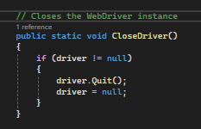
- public static void CloseDriver(): This method closes the WebDriver instance, quitting the browser.
The Init method uses a switch statement to handle different browser options. Depending on the browser specified, it initializes the corresponding WebDriver. It also includes options for connecting to a Selenium Grid when using "ChromeDocker" or "FirefoxDocker". The method ensures that the driver is not null after initialization and maximizes the browser window.
This class provides a convenient way to manage WebDriver instances, navigate to URLs, and initialize drivers for various browsers in a Selenium-based test automation framework.
DOCKER
Setting up Selenium Grid with Docker involves a few steps. Here's a step-by-step guide on how you might have set up your Selenium Grid and run your tests:
Step 1: Install Docker
Make sure Docker is installed on your machine. You can download it from the official Docker website.
Step 2: Start Docker Desktop:
After installation, launch Docker Desktop.
Step 3: Verify Docker Installation:
Open a terminal or command prompt.
Run the following command to check that Docker is installed and running:
```docker --version
You should see the Docker version information if the installation is successful.
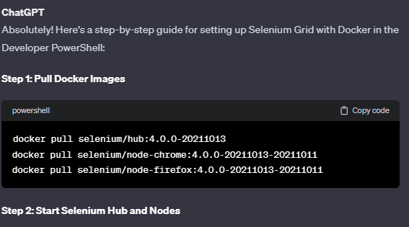
``` docker run -d -p 4444:4444 --name selenium-hub selenium/hub:4.0.0-20211013
docker run -d --link selenium-hub:hub selenium/node-chrome:4.0.0-20211013-20211011
docker run -d --link selenium-hub:hub selenium/node-firefox:4.0.0-20211013-20211011
Note: If you encounter issues with "manifest unknown," you can try the following:
docker run -d -p 4444:4444 --name selenium-hub selenium/hub:4.0.0-20211013
docker run -d --link selenium-hub:hub selenium/node-chrome:4.0.0-20211013
docker run -d --link selenium-hub:hub selenium/node-firefox:4.0.0-20211013
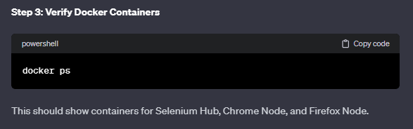
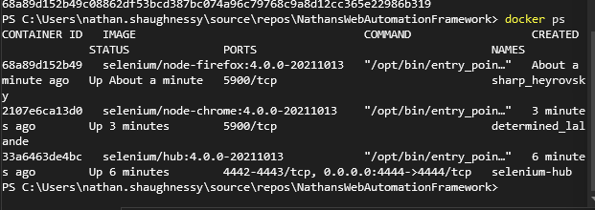
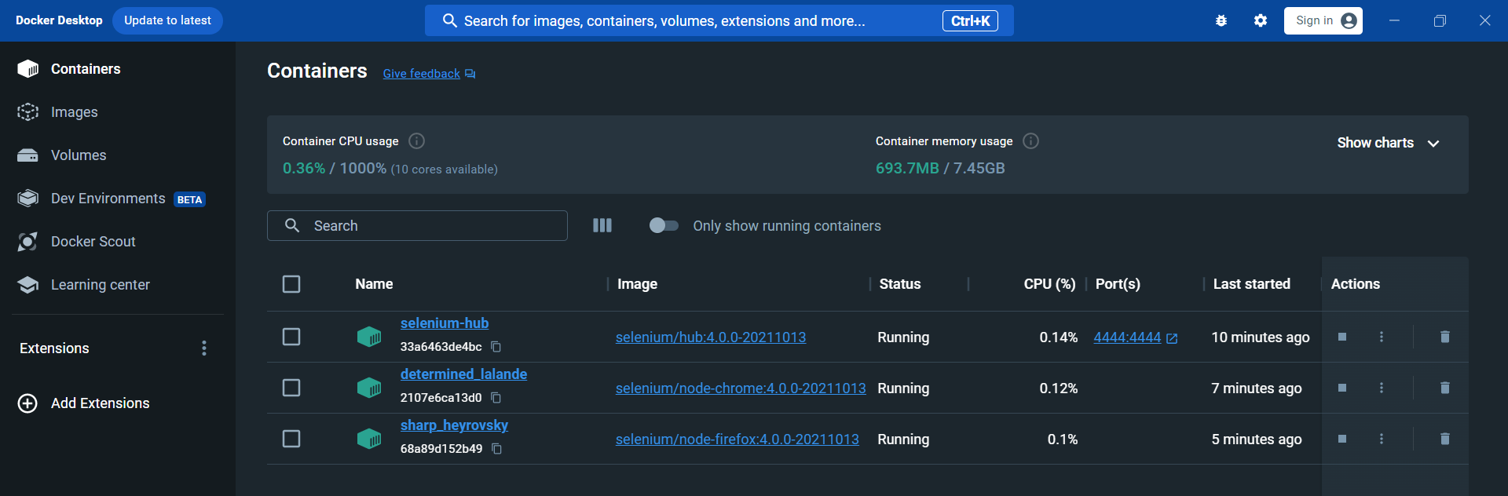
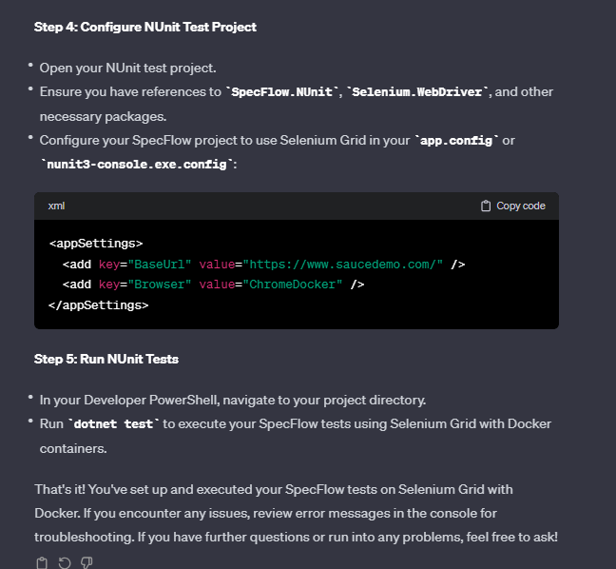
So for Docker, I change the parameters in the test runsettings:
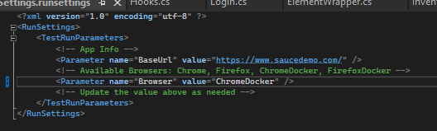
Dotnet test
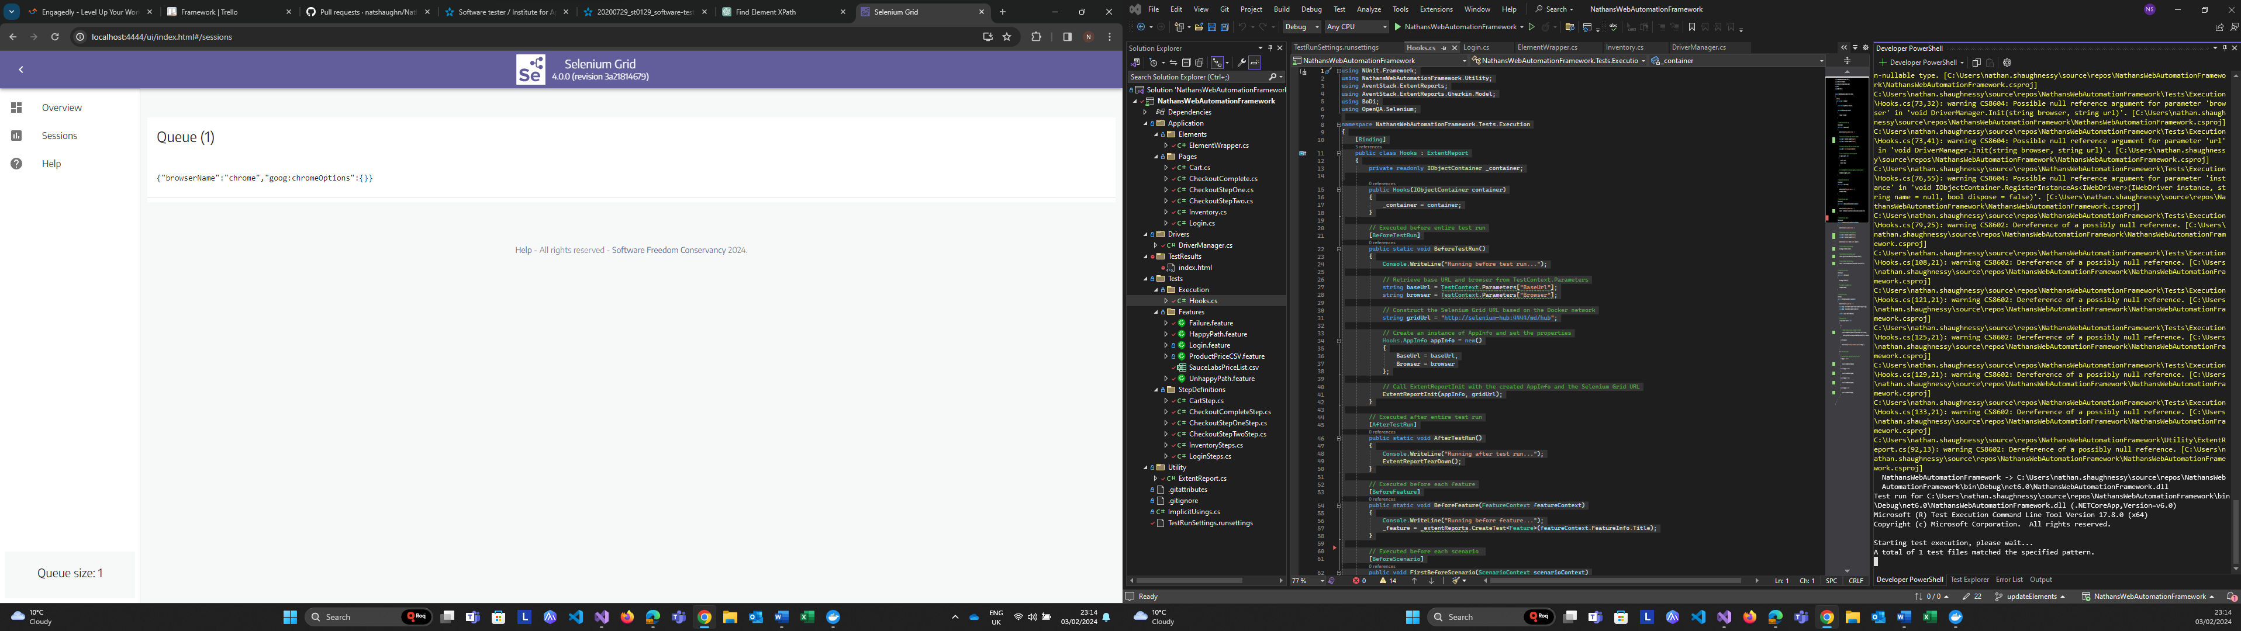
Didn’t work so did:
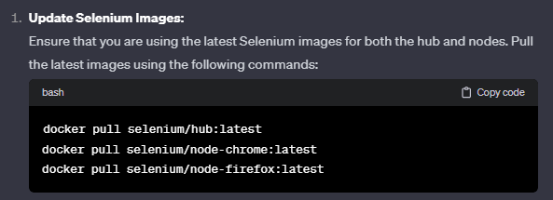

Docker Video:
Docker Crash Course for Absolute Beginners [NEW] (youtube.com)
Docker is a virtualisation software, makes developing and deploying software easier. Docker packages application into a container that has everything needed to run the application. Code, libraries, run time, environment configuration etc.
With containers, don’t need services directly on operating system. Own isolated environments. Start service with single docker command which fetches container package form the web and starts it on the computer, same on whatever Operating system etc. So deployment before containers was a lot of effort. All now done in one Docker artifact with what application needs. The run Docker commands to fetch and run the docker artifacts. Install docker runtime on the server.
Advantages over VM. Docker don’t need to install services directly onto an operating system.
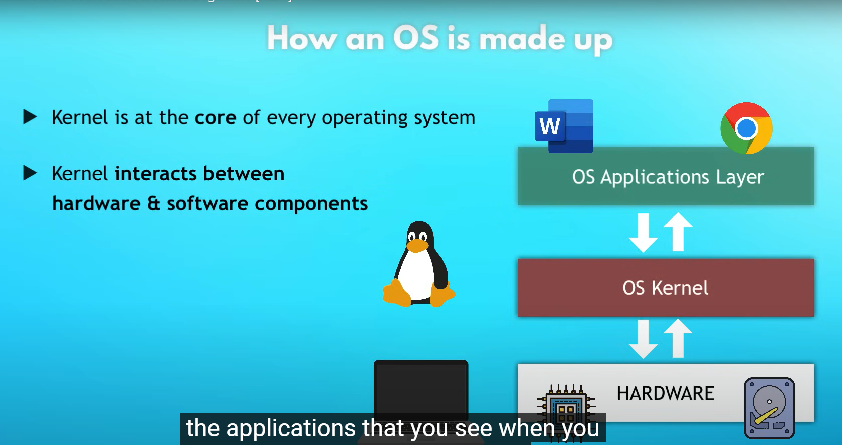
Docker virtualises the application layer.
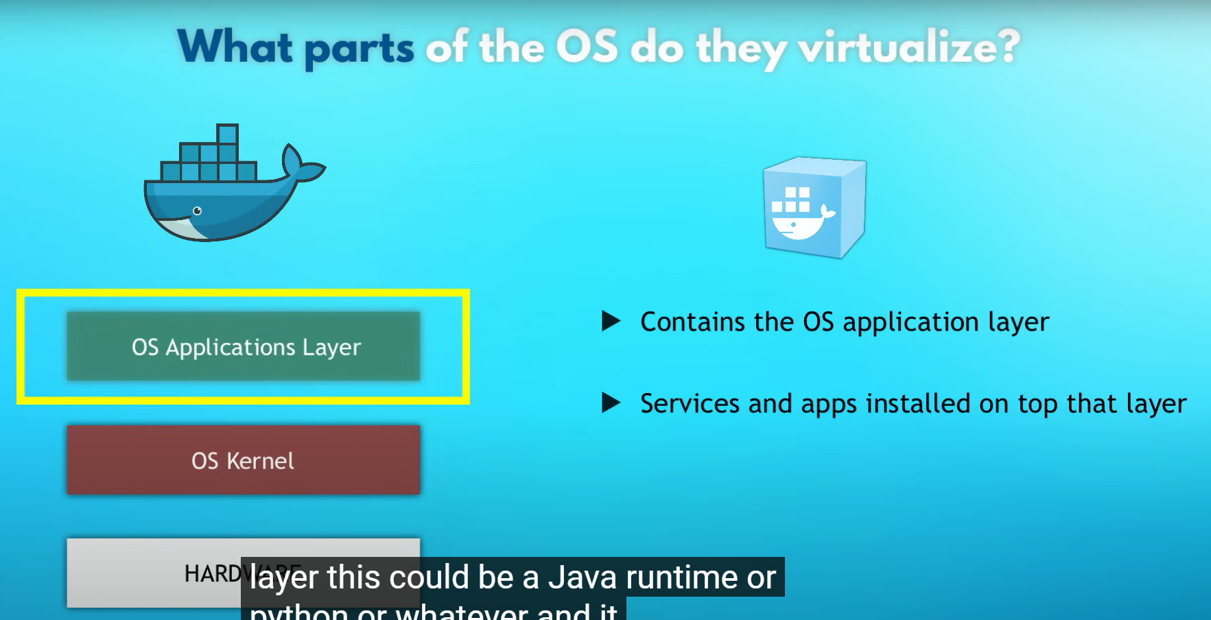
VM’s virtualises the complete Operating system (OS).
So docker images much smaller, only implements one layer. VM images can be much bigger as they do kernal as well as app layer. Containers take seconds to start for docker, quicker that VM’s. Not everything compatible with docker though i.e., Linux on Windows won’t run.
FIRST install docker on my local machine. Docker desktop is now installed.
Images vs Containers
Docker allows to package environment of app = docker image. Application artifact. Not only has compile code, but also environment configuration, OS layer, plus tools like packages programming languages written in it, C# dotnet. Environment variables, like run settings. Package is called an image.
So a container = take package/ image, download to server to run on the local computer, when we run that image on OS and app starts in configured environment then we get the container. So RUNNING INSTANCE OF AN IMAGE IS A CONTAINER. From one image you can run multiple containers, to run multiple instances of the applications.
Docker ps in cmd line. Show’s
Docker registries. Ready docker images: https://hub.docker.com/
So I do to docker hub which is the default location where docker looks for any images I specify: https://hub.docker.com/search?q=selenium and have searched for selenium hub, clicked on it, then I have ran the Docker Pull command: docker pull selenium/hub
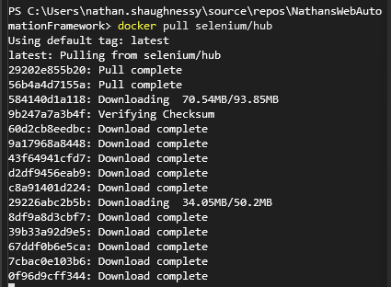
Then running docker images we see this:
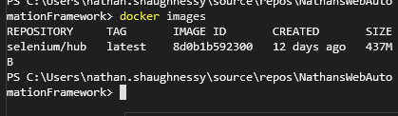
Then do these:
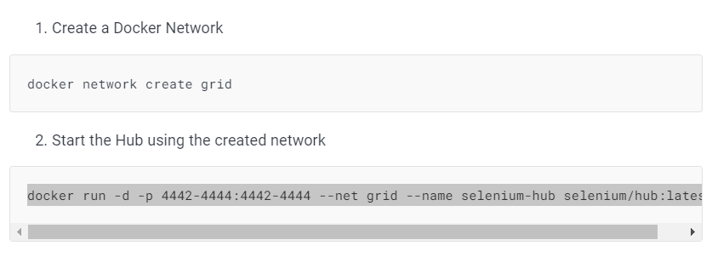
docker network create grid
docker run -d -p 4442-4444:4442-4444 --net grid --name selenium-hub selenium/hub:latest
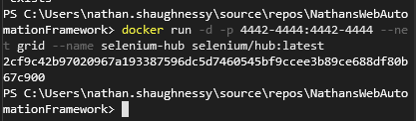
That command starts the container from the image.
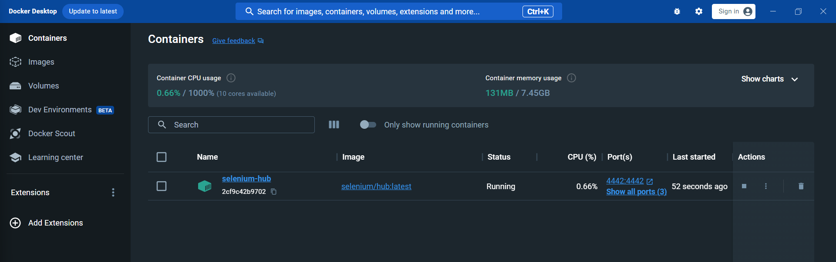
Using -d detached docker process from terminal, so it doesn’t block the terminal for us.
Step 3. Start the node using the created network, as I am using PowerShell this is what the docs show:
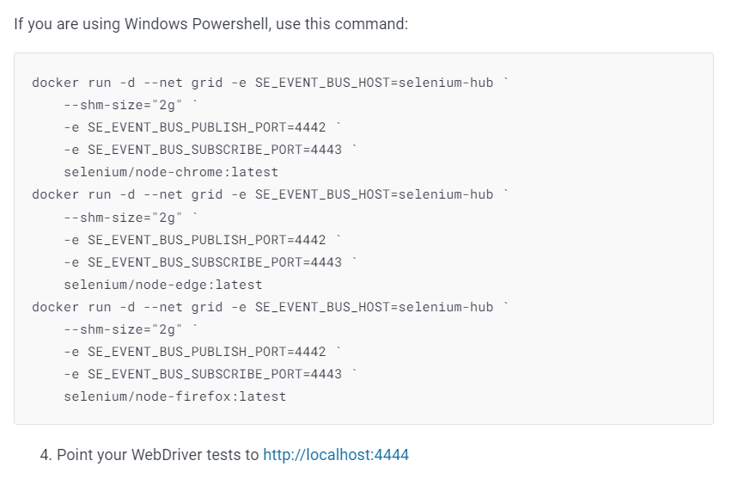
So for chrome node: https://hub.docker.com/r/selenium/node-chrome I can do this:
docker run -d --net grid -e SE_EVENT_BUS_HOST=selenium-hub `
--shm-size="2g" `
-e SE_EVENT_BUS_PUBLISH_PORT=4442 `
-e SE_EVENT_BUS_SUBSCRIBE_PORT=4443 `
selenium/node-chrome:latest
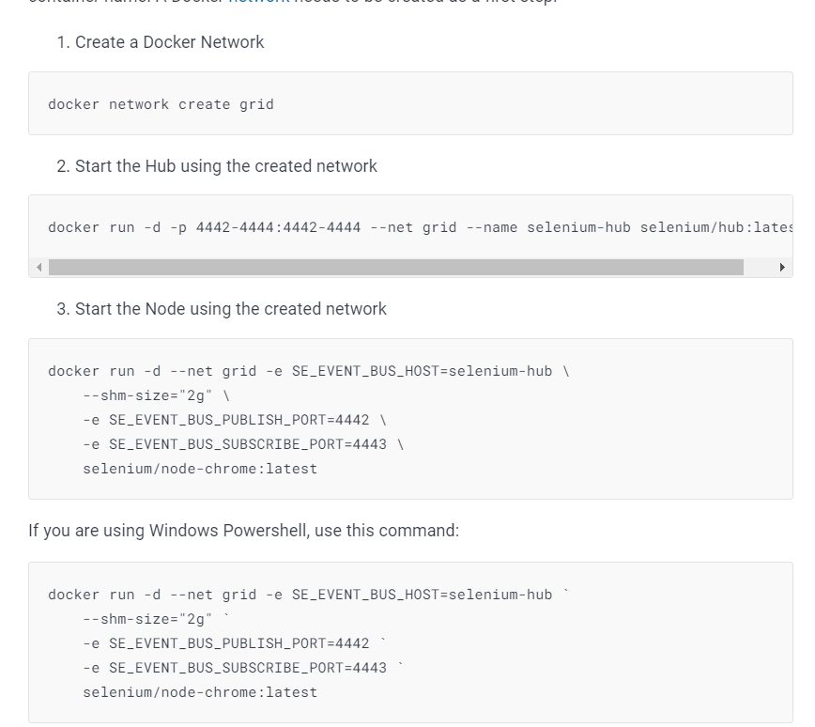
=
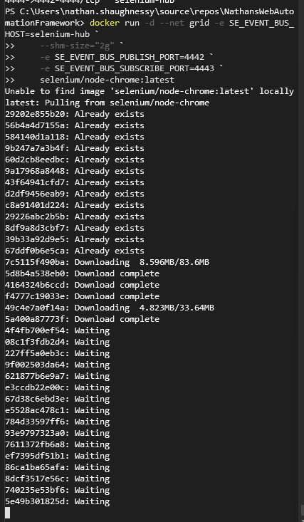
=
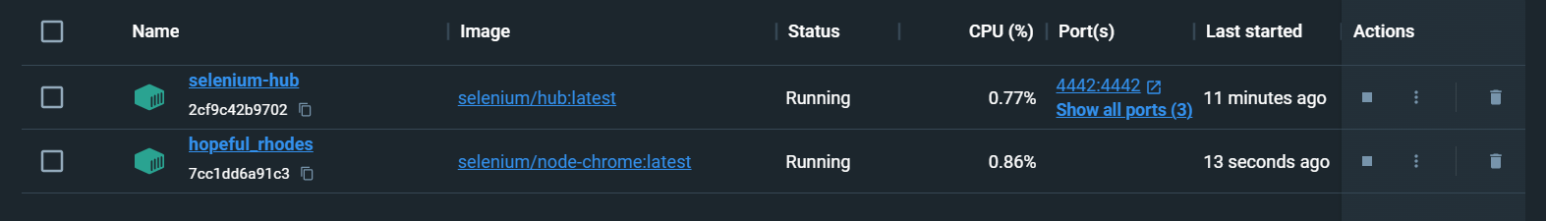

For firefox node https://hub.docker.com/r/selenium/node-firefox:
docker run -d --net grid -e SE_EVENT_BUS_HOST=selenium-hub `
--shm-size="2g" `
-e SE_EVENT_BUS_PUBLISH_PORT=4442 `
-e SE_EVENT_BUS_SUBSCRIBE_PORT=4443 `
selenium/node-firefox:latest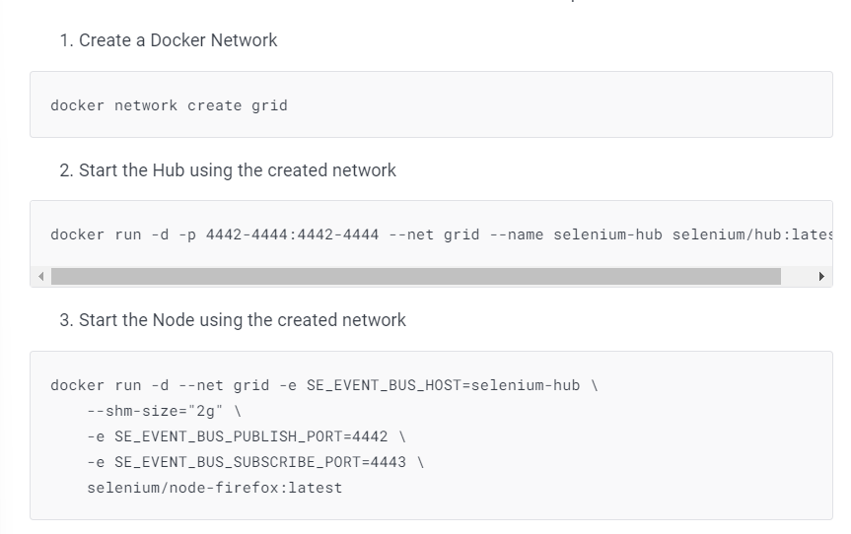
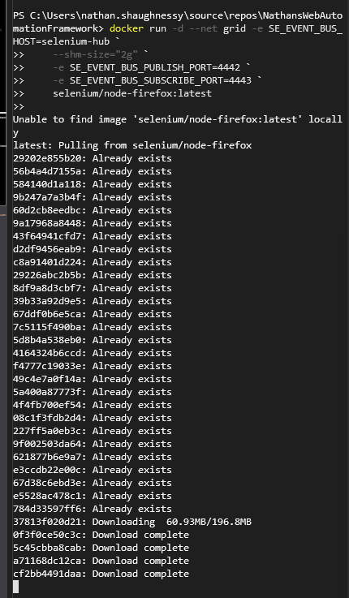
=
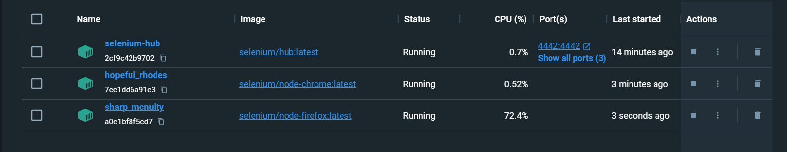

Then when I go to http://localhost:4444/ui I see this:
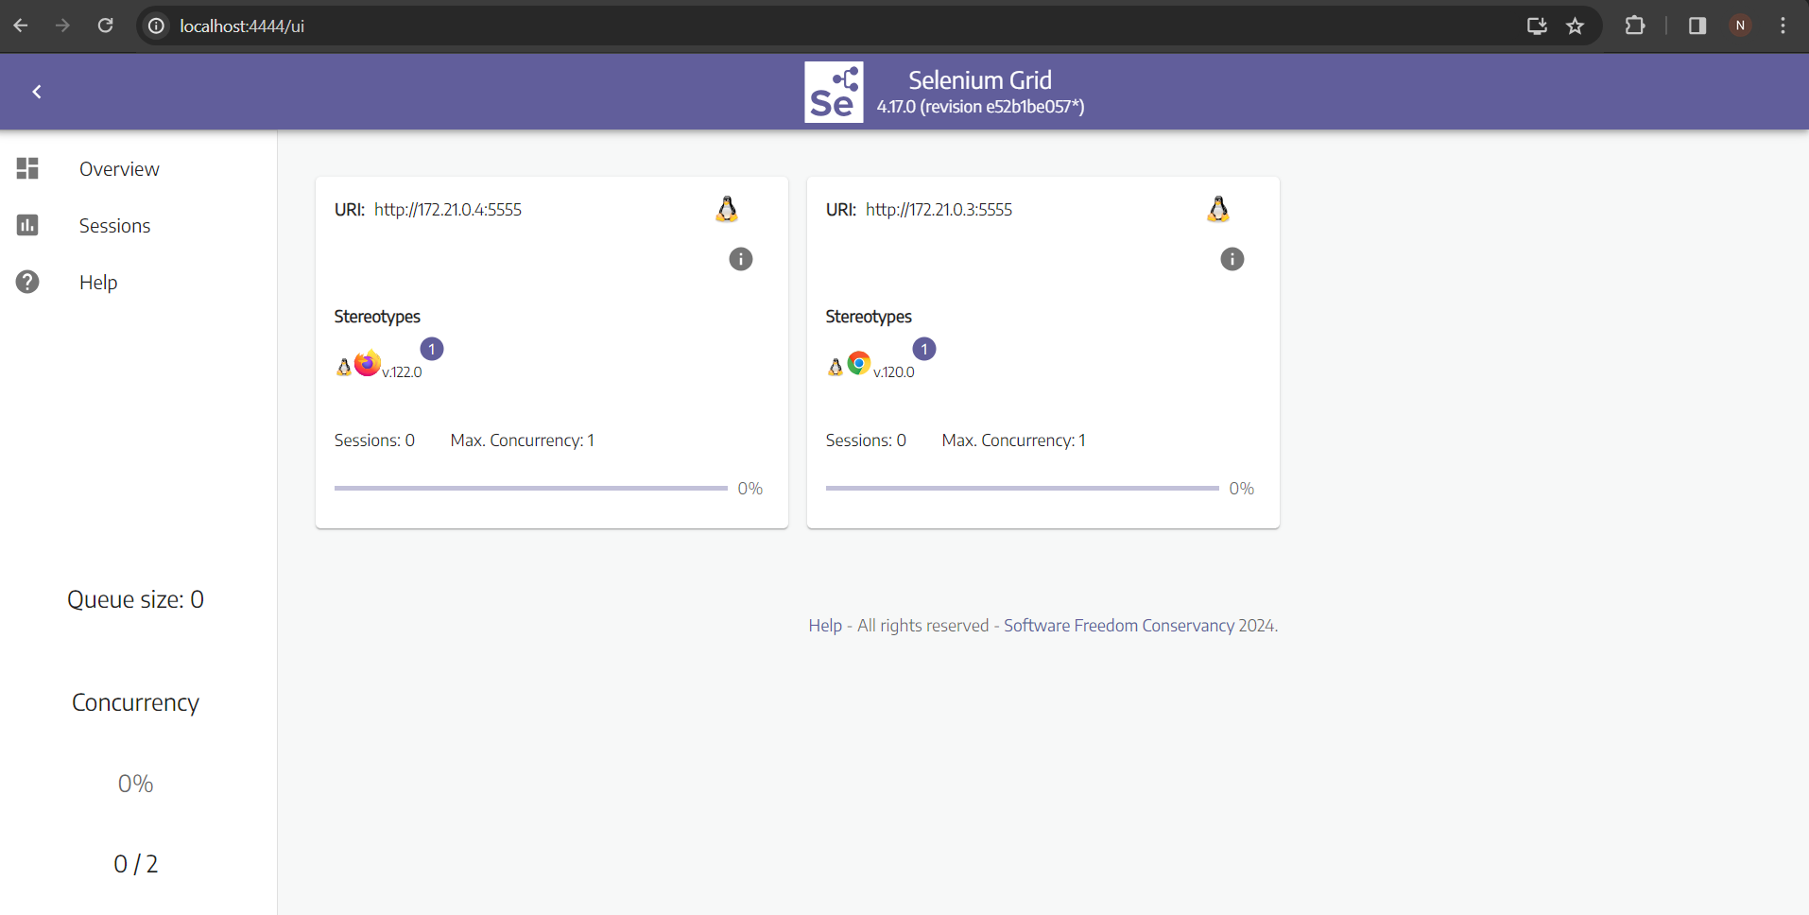
All running
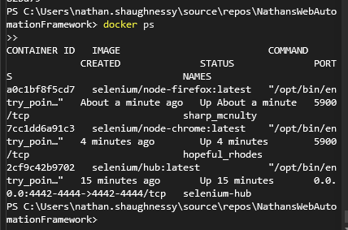
That’s working now!!!!
Argument for changing my driver manager class:
If you change your code to use http://selenium-hub:4444 instead of http://localhost:4444, the key thing is that you need to ensure your test execution environment can resolve the hostname "selenium-hub" to the correct IP address.
In your case, as you have observed the Selenium Grid UI at http://localhost:4444/ui, it means that the hostname "selenium-hub" is already correctly configured to point to the Selenium Hub container within the Docker network.
Here's how you can proceed:
Keep Using "localhost" (if running locally):
If you are running your tests on the same machine where Docker is running, and your Selenium Grid is accessible at http://localhost:4444/ui, you can continue using localhost:4444 in your code.
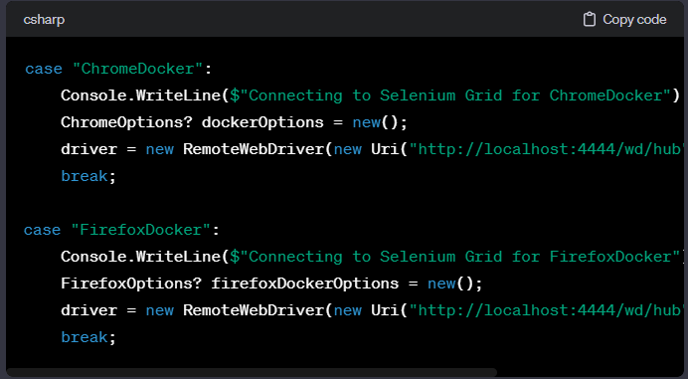

Use "selenium-hub" (if running on a different machine):
If you plan to run your tests on a different machine or in a different environment, and you have configured the hostname "selenium-hub" to resolve to the correct IP address (e.g., via DNS or the hosts file), then you can use this approach.
CHANGE THE URI TO THE BELOW
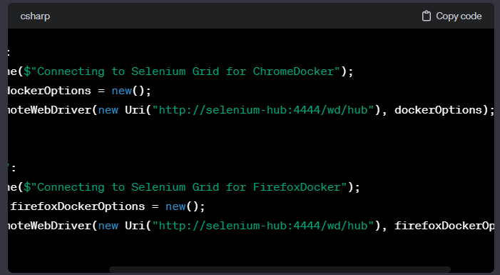
In either case, the key is to ensure that the URL used in the RemoteWebDriver constructor matches the address of your Selenium Hub, and it seems like both approaches should work based on your current setup.

STOP the containers via the app and restart again when required to run dotnet test after changing runsettings file:
Yes, that's correct! Stopping the Docker containers using the Docker Desktop app will effectively shut down the Selenium Grid and the associated browser nodes. When you come back later and start the containers again using the Docker Desktop app, you can run your tests using dotnet test, and they should work as expected.
Here's a quick overview of the process:
Stopping the Docker Containers:
In the Docker Desktop app, stop the containers for Selenium Hub, Chrome Node, and Firefox Node.
Starting the Docker Containers:
In the Docker Desktop app, start the containers for Selenium Hub, Chrome Node, and Firefox Node.
Running Your Tests:
Open a terminal or command prompt.
Navigate to the directory containing your test automation framework.
Run your tests using dotnet test.
This workflow allows you to manage your Dockerized Selenium Grid and browser nodes separately from your test automation framework. When you need to use them, start the containers; when you're done, stop the containers.
Remember that stopping the containers will lose any state or data within the containers, so if you have any specific configurations or data persistence requirements, consider Docker volumes or other strategies accordingly.
STOPPED IN THE APP
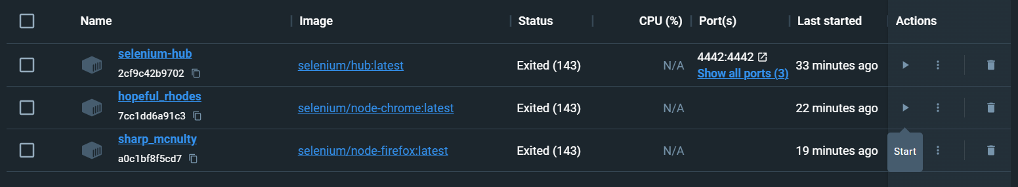
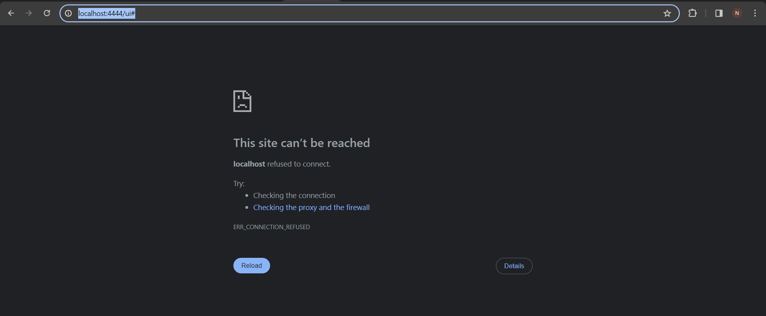
The dotnet test doesn’t work
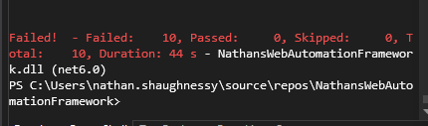
Turn them back on:
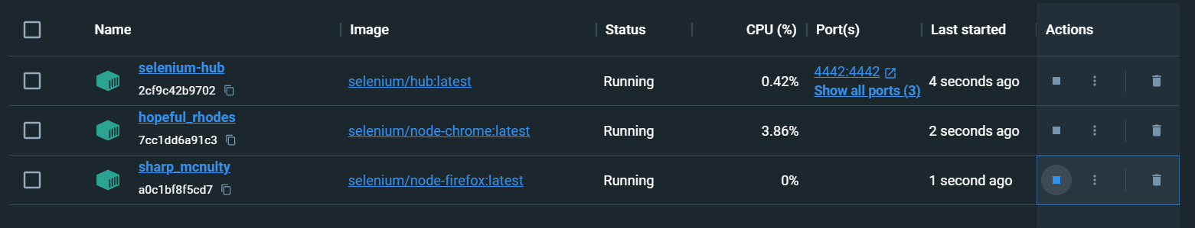
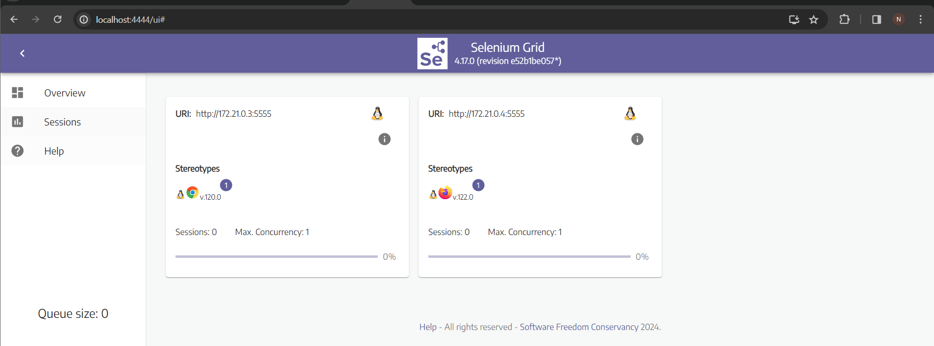
Dotnet test works

For this: Configure a continuous integration tool to build your code upon checking it in to the remote repository and report the build status. Additionally, configure a job to run the tests on a scheduled basis and have the results of the tests viewable within that tool.
I watched this video and used info from this that was relevant to my requirement: https://www.youtube.com/watch?v=6w440IrjIIM
As it was BDD specflow project using selenium WebDriver, and how I could load it up to azure devops and create a pipeline job to execute my specflow tests.
As it’s specflow project I have the specflow nuget package/ libraries, selenium libraries, using nunit so have that package, and downloaded a couple of other packages as the video mentioned they would help as using nunit and I want to be executing these through ADO.
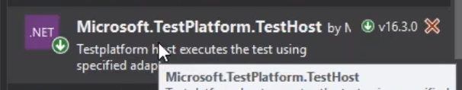
This installs necessary libraries and executables for using VS Test on Agent machines, so I don’t actually need this – if I want to execute tests on remote machines, and that machines does not have Visual Studio installed, then that library is required. That library will get all necessary files to be able to execute tests without VS.
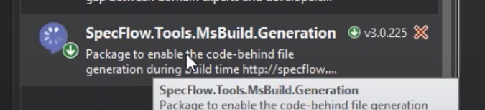
This library used as using specflow and .net core so this is the tool generator library for that.
.net core project – when publish that project, the chrome and firefox etc wouldn’t be published to output so making changes to the csproj means that – this bit:
Will publish the required info.
So to start with I created a new pipeline. And I chose to do this using the classic editor option at the bottom instead of using a YAML file. Then I imported my GitHub repository. I then chose ASP .NET Core as the framework is using .net. I was then given a set of pre defined steps.
Click on Pipeline, shows info about it.
Click on Get Sources, shows where sources files are coming from – source files in GitHub repo.
In the Pipeline section I changed the name to say it is about specflow. The agent pool is ADO, so I left that. And chose Windows latest as that is what I have built the framework on.
Restore: Restores NUget packages and any dependencies, using csproj file to do that.
Build: Once restored, I build the project based on the csproj file, in the arguments, I said I don’t need to do a restore as I have that as a separate step. Good to split them up as if anything goes wrong I can identify exactly what went wrong. Identify the problem.
Test: REMOVED THIS ONE AS ADDED VSTEST LATER
Publish: Once built the project I can publish it, and again I removed the auto default build bit, so added no build switch as it’s already done above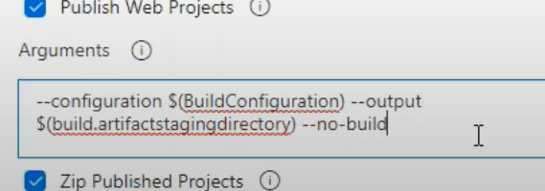
Also unticked ‘Publish web projects’ as it’s not a web project, and unticked Zip published projects & Add project’s folder name to publish path. As all I want to do is publish the project once it is built.
Publish Artifact: Finally, the output of all the compiled files created, I want to publish those to ADO to be reused later for other pipelines if required.
Then did save and queue, save and run and ran the pipeline. That was all successful. That build was successful, can see the output in ADO. Now build was successful, I went back to the build, clicked on edit: pulling code, building it but not executing tests yet, so I added a step:
Searched for VSTest and added that as a step. Test files, I changed it from the original because I know the name of the project: and added my project name into there:
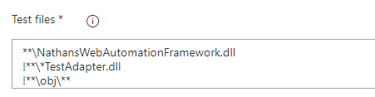
Then once that’s added, that step using Microsoft vs test – which identifies my tests in the project and executes them and produces/publishes results for me. Save queue run and it runs. Build run:
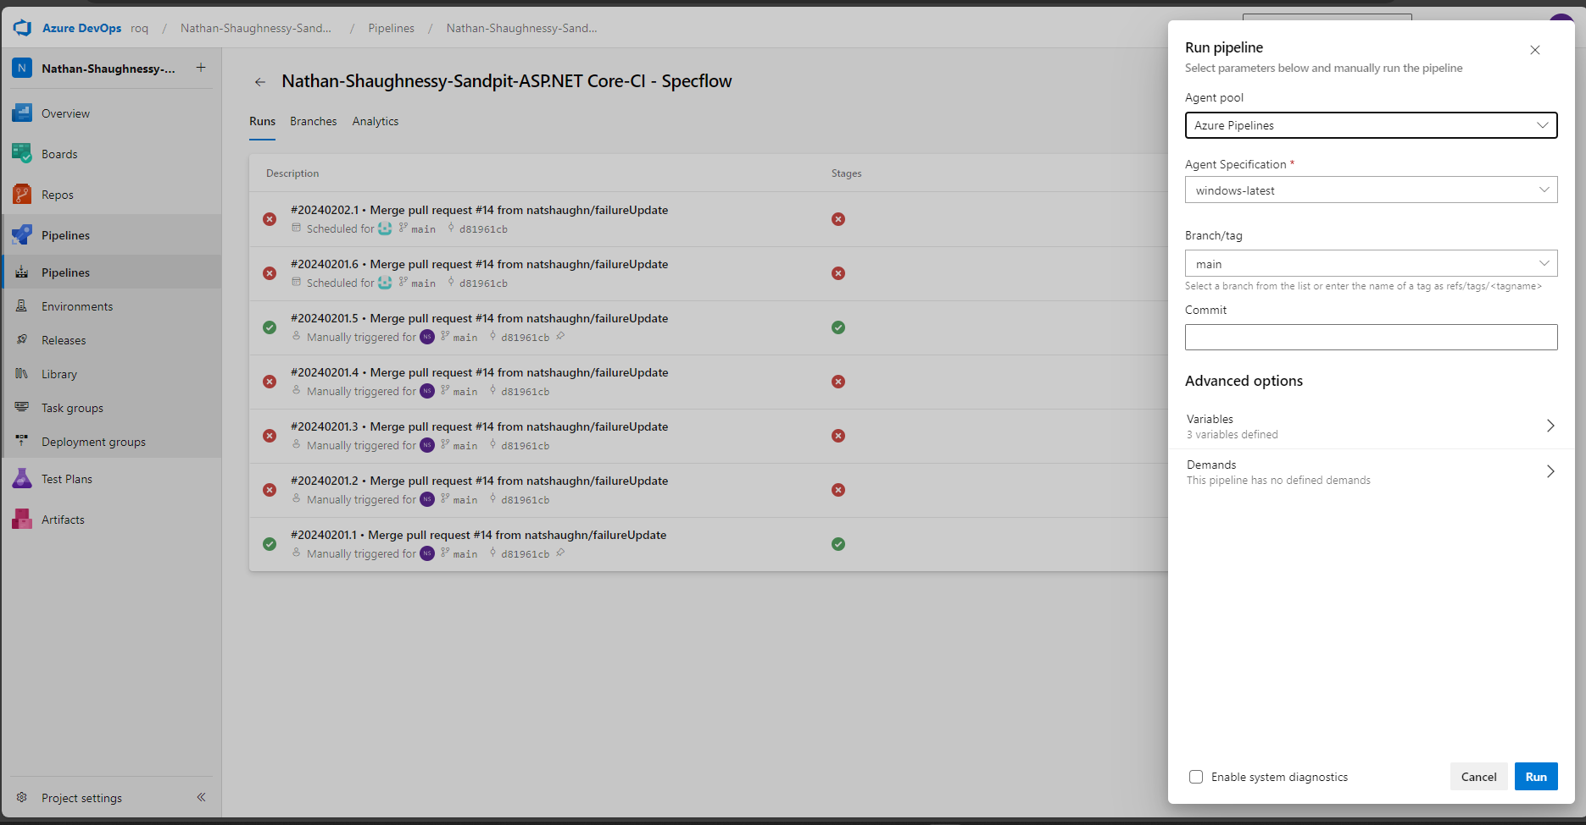
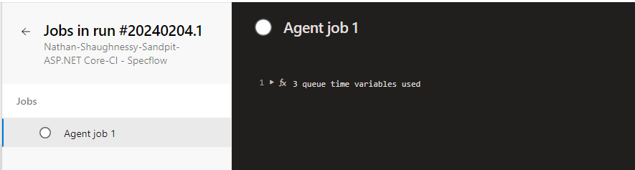
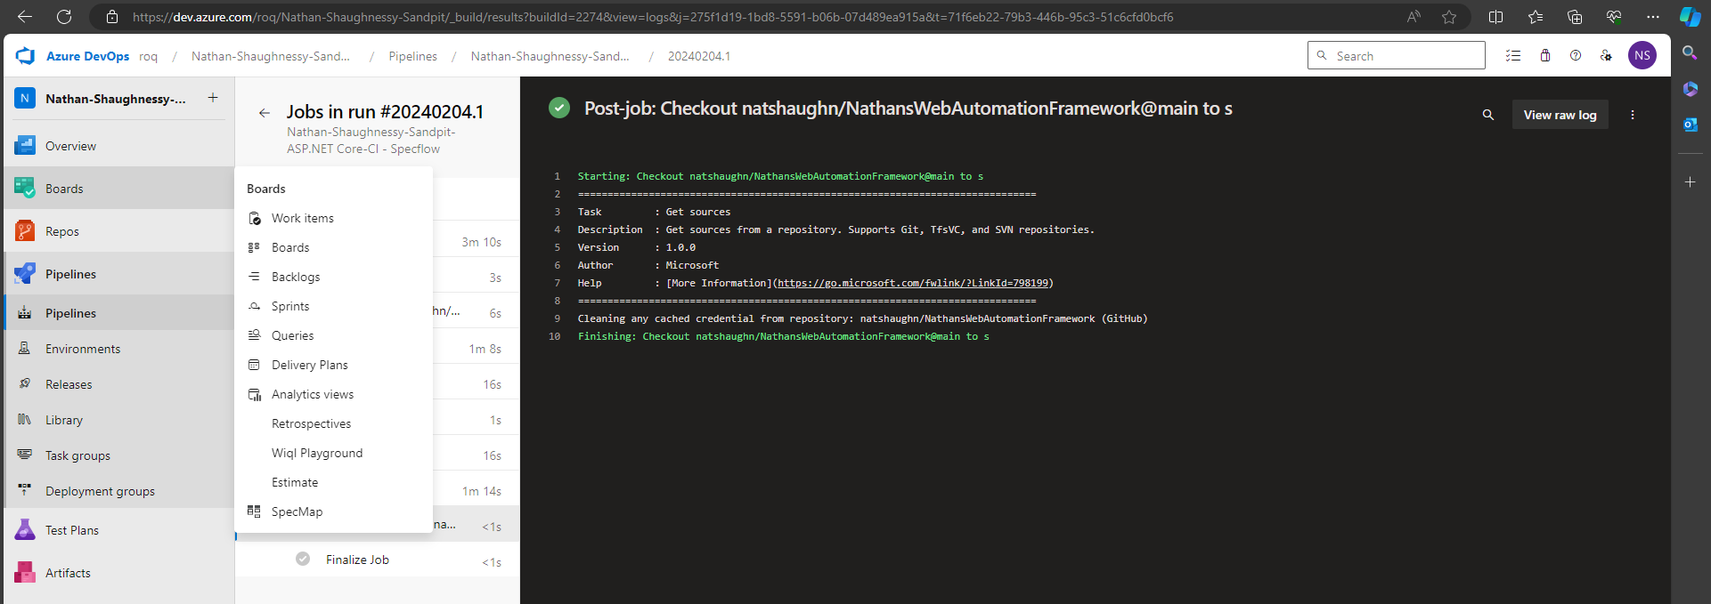
Showing as failed as there’s a failed test regarding the requirement.
Click on tests, can see results. Can filter, show passed.
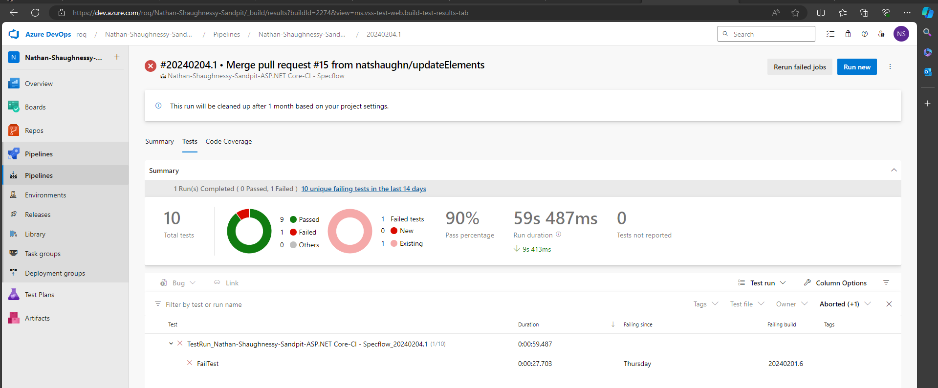
Failed test logs:
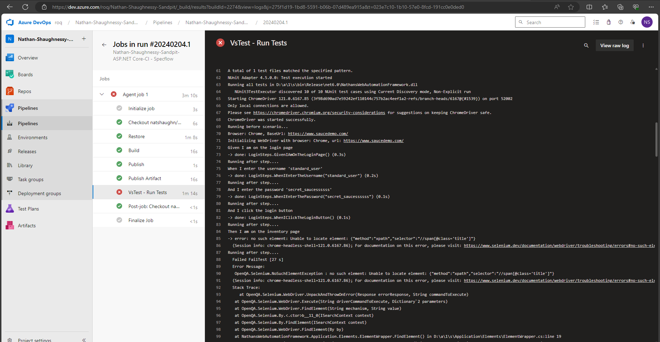

Setting up scheduled tests was simple. Click on the pipeline, click edit, go to triggers, click add and schedule.
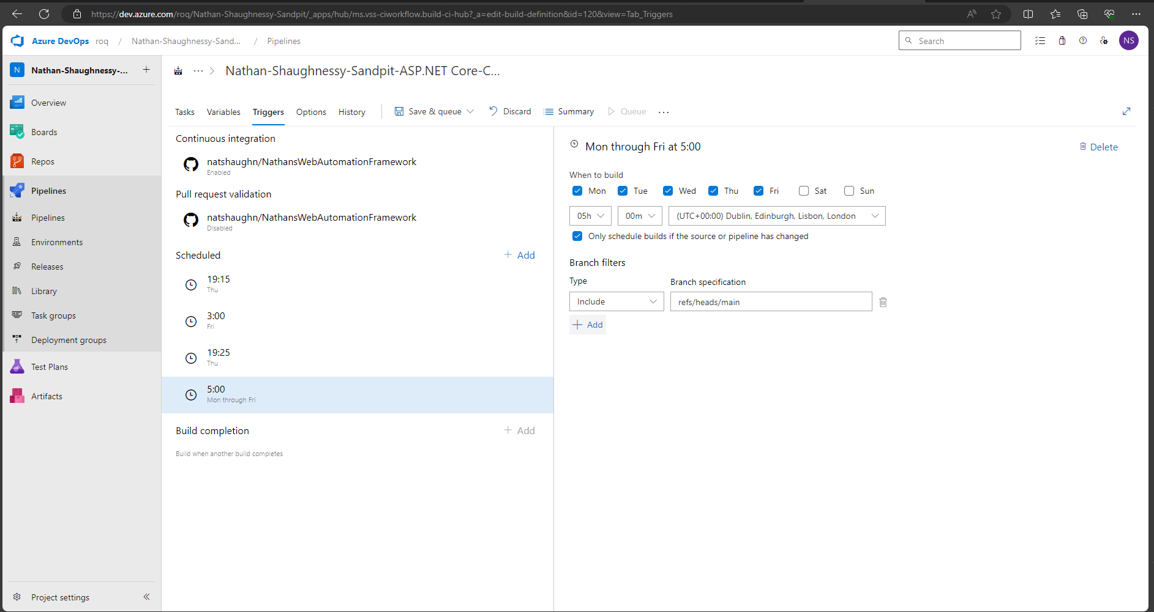

So the CI running on ADO is set up here after making pipeline, same place as triggers:
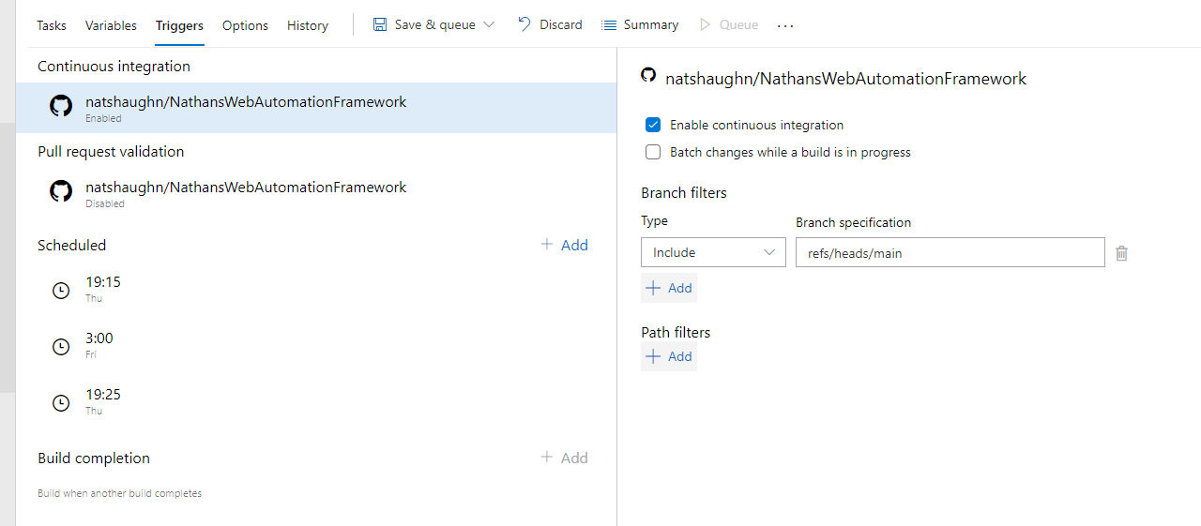
CI in action:
Just pushed a change on github:
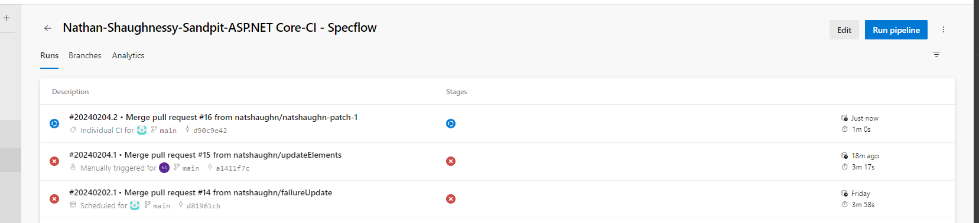
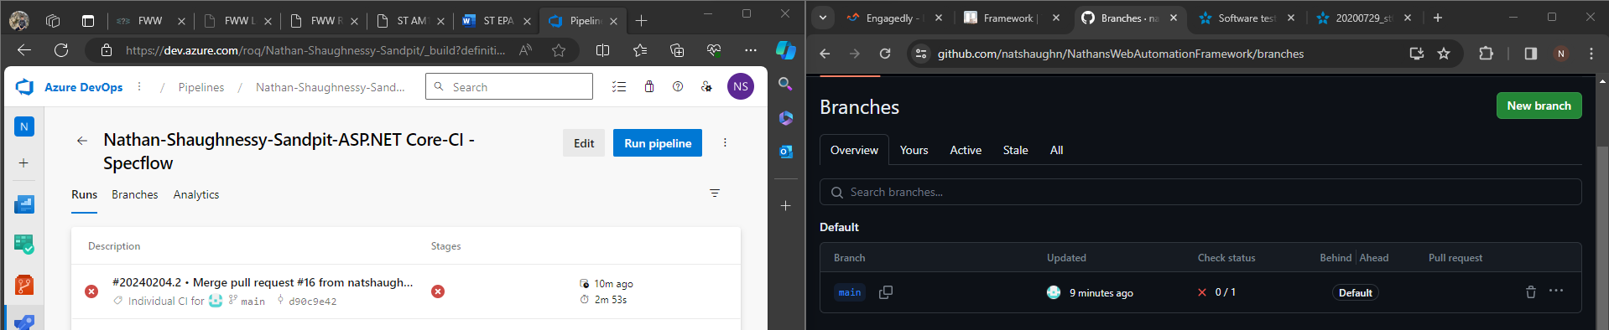

Set up an agent –
Click on Agent in here:
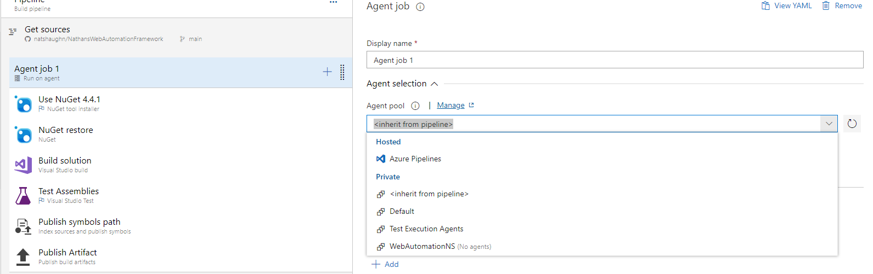
There is is
ASK GRAHAM HOW TO SET ONE UP
Or can I use the Hosted Azure Pipelines one? Inherit from Pipeline

Hi Graham, when using Azure Pipeline’s as the CI tool, I’ve set it up like this: 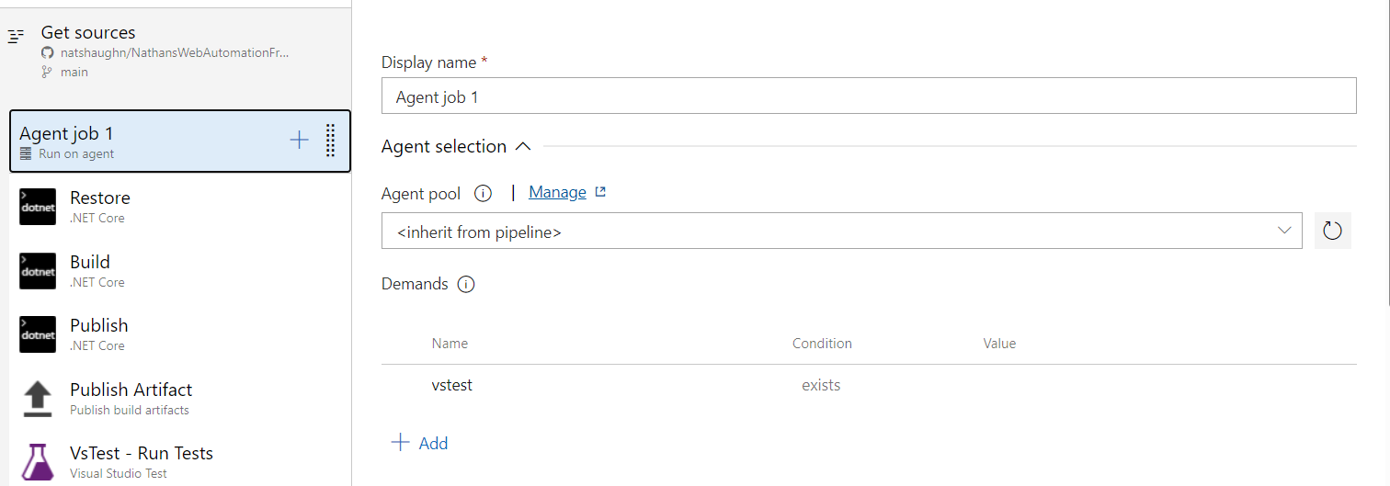
And I can see my results here:
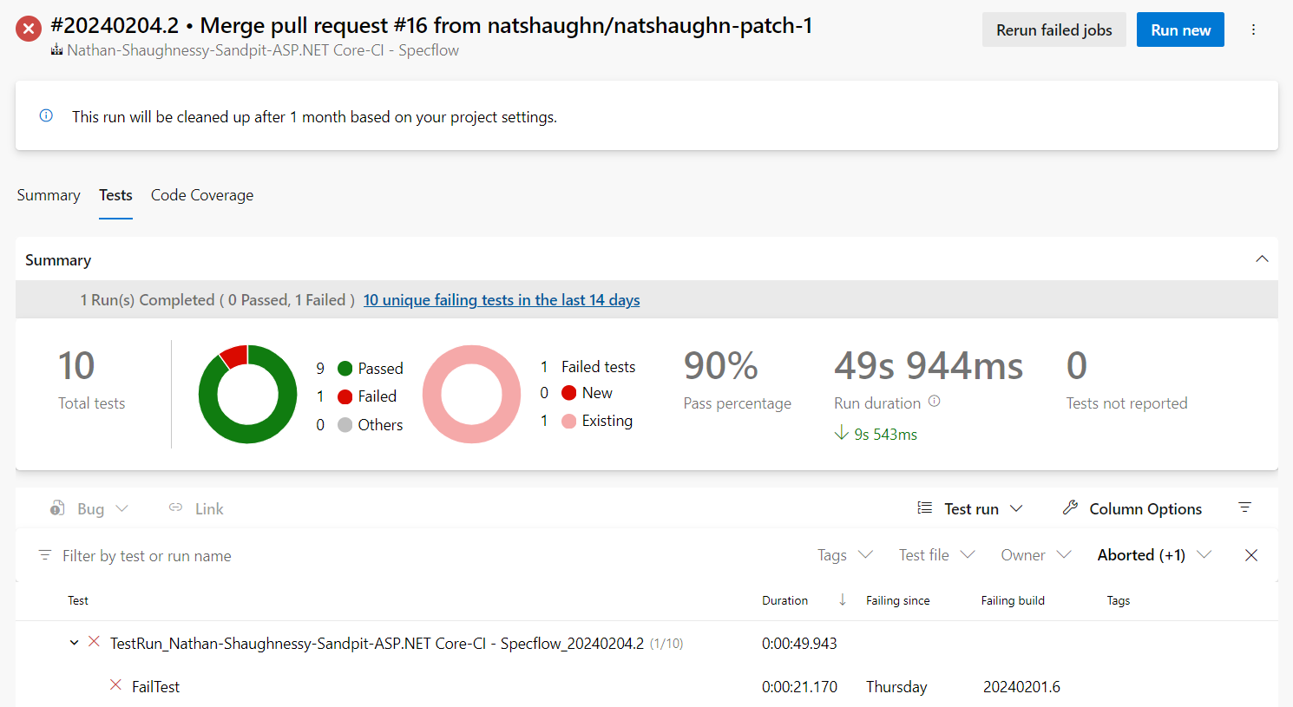
Will I need to create my own Agent or can I use the pre-populated one? – Can use pre populated but try and make own agent when have time.
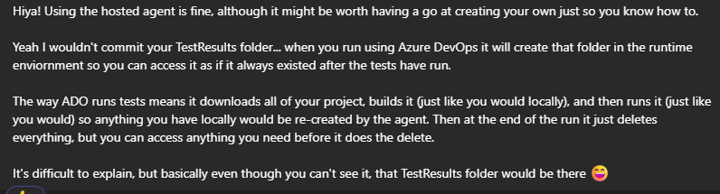
Made a change to myHooks in the After Step section.
https://learn.microsoft.com/en-us/azure/devops/pipelines/test/ui-testing-considerations?view=azure-devops&tabs=nunit#capture-screenshots
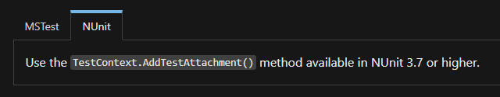
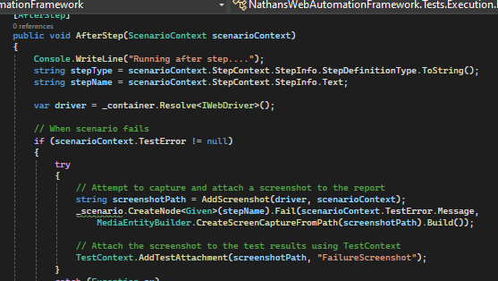
https://www.youtube.com/watch?v=nW9RaH8xp_E&t=210s

PIPELINE LINK
Pipelines - Run 20240208.2 (azure.com)

SET UP AGENT LINK
Settings · Agent pools (Nathan-Shaughnessy-Sandpit) - Settings (azure.com)

Coding club:
